HPC Competition Report
Qwen 3 14B Training on Romeo Cluster
Team: Asoiu (Azerbaijan)
Parameter | Value
Hardware | 1 Node x 4x NVIDIA GH200 (120GB) GPUs
Model | Qwen 3 14B (~14.77B parameters)
Dataset | FineWeb-Edu (~6M tokens, local Parquet)
Framework | MaxText (JAX-based)
Training Epochs | 5
Sequence Length | 2048 tokens

Task 1: Training Optimization

Overview
We ran multiple training configurations to maximize throughput while keeping final loss below 1.9. All runs used fixed settings: max_target_length=2048, num_epoch=5, the provided Orbax checkpoint, and FineWeb-Edu dataset.

Experiments

Run 1 — Baseline (FSDP=4, batch=1)
The starting point. Full FSDP across all 4 GPUs with batch size of 1.
- Average Tokens/s/device: ~2,235
- Final loss: 0.97
- Total steps: 3,182
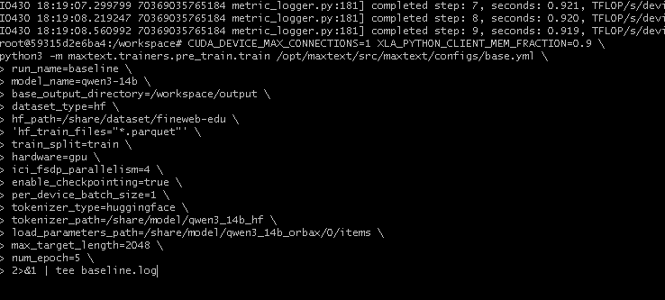

Run 2 — Increased Batch Size (FSDP=4, batch=2) — BEST RUN
We doubled the per-device batch size. This is our best configuration.
- Average Tokens/s/device: ~2,468
- Final loss: 1.62
- Total steps: 1,522
- Throughput improvement: +10.4% vs baseline
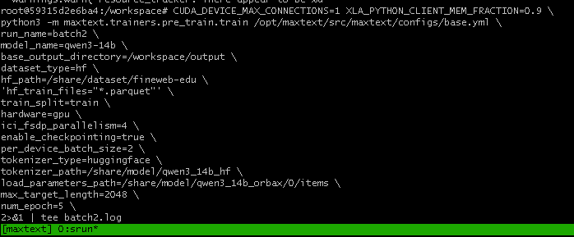

Run 3 — Mixed Parallelism (FSDP=2, Tensor=2, batch=2)
We split parallelism between FSDP and Tensor Parallelism to reduce shard size.
- Average Tokens/s/device: ~1,950
- Result: WORSE than batch=2 — extra communication overhead on 4 GPUs hurt performance
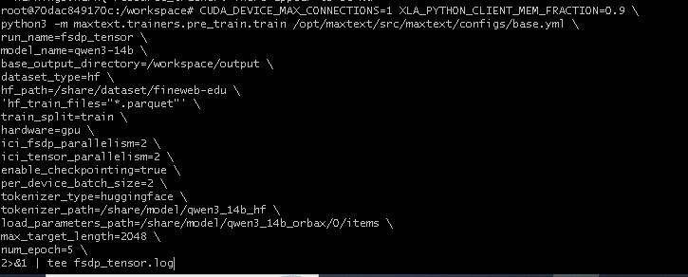
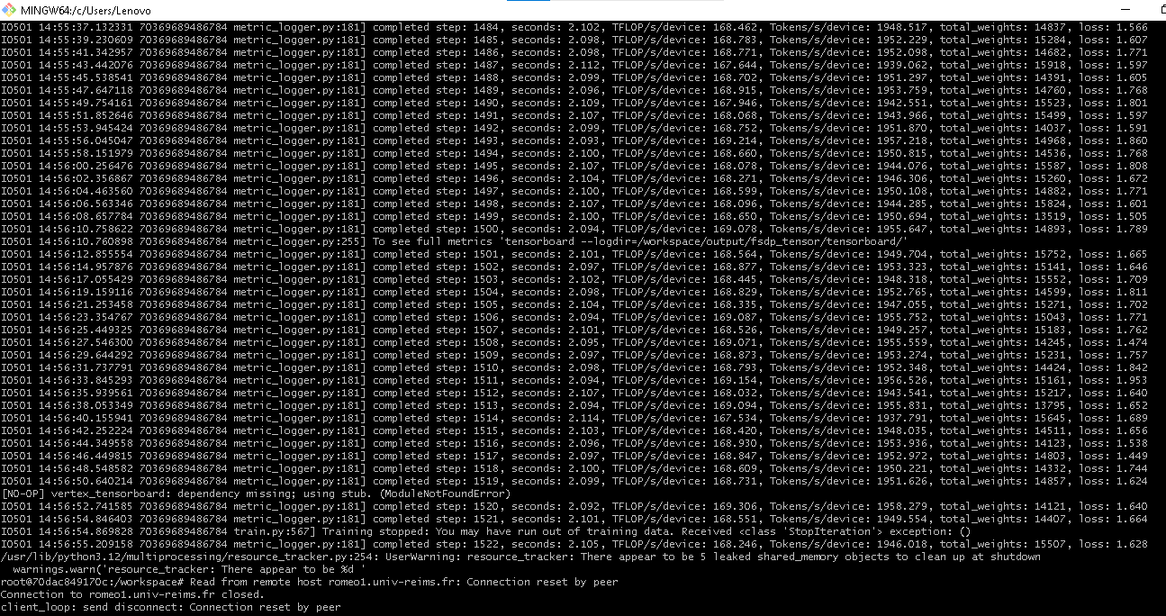

Run 4 — Gradient Accumulation (FSDP=4, batch=1, grad_acc=2)
We tried gradient accumulation to simulate larger batch without more memory.
- Result: OOM crash — GPU memory exhausted during checkpointing
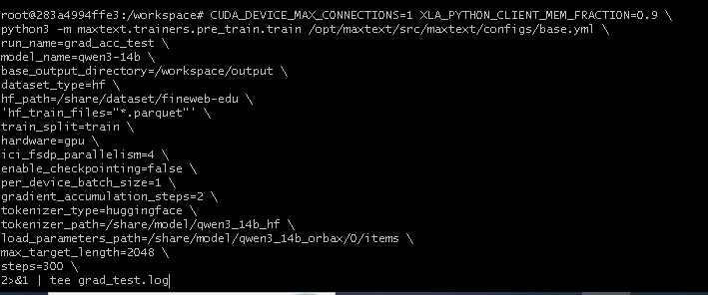
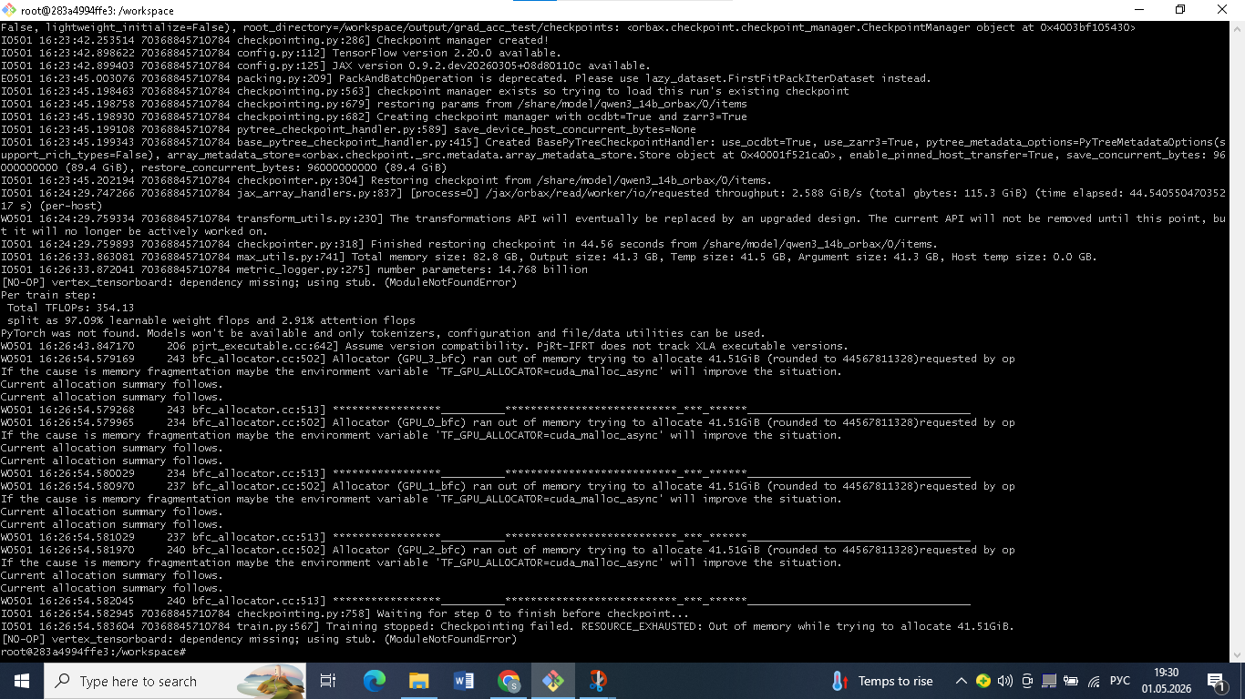

Best Configuration
ici_fsdp_parallelism=4 | per_device_batch_size=2 | max_target_length=2048 | num_epoch=5

Results Summary
Configuration | Tokens/s/device | Final Loss | Status
Baseline (batch=1, FSDP=4) | ~2,235 | 0.97 | Pass
batch=2, FSDP=4 (BEST) | ~2,468 | 1.62 | Pass - Best
FSDP=2 + Tensor=2, batch=2 | ~1,950 | 1.62 | Pass
Grad Accumulation (acc=2) | — | — | OOM Crash

Total training throughput for the best run was approximately 9,872 tokens/s across 4 GH200 GPUs (computed as average Tokens/s/device × number of devices, excluding the first 10 warmup steps).

Analysis
Increasing batch size from 1 to 2 improved GPU utilization by ~10% without adding communication overhead. Each GPU processed more tokens per step, keeping the GPUs busier. Mixed parallelism (FSDP+Tensor) added extra synchronization between GPUs that was not worth the cost on only 4 devices. Gradient accumulation failed because saving a checkpoint while holding model weights and accumulated gradients simultaneously exceeded GPU memory limits.

Note:
Final checkpoint saved to /gpfs/projet/r250119/Submit/r250119-u7/checkpoints/ on the Romeo cluster for verification.

Task 2: Profiling & Analysis

Setup
We profiled the best configuration (batch=2, FSDP=4) using profiler=xplane for 10 steps, capturing step 9 as a steady-state profile. The trace file was opened in Perfetto UI (ui.perfetto.dev).
- Hardware memory usage: 41.27 GB / 85.5 GB per GPU (48.3%) for model parameters
- Profiled step time: ~1.75 seconds
- Profiled Tokens/s/device: ~2,341 (slightly lower due to profiler overhead)

Question 1: Communication Mapping
We identified all three NCCL collective operations in the trace:

Operation | Count | Role | Parallelism Strategy
AllGather (RING_LL) | 8,072 | Reconstruct full weight shards before forward/backward | FSDP
ReduceScatter (RING_LL) | 1,288 | Distribute gradients across GPUs after backward | FSDP
AllReduce (RING_LL) | 352 | Gradient/optimizer state synchronization | Data Parallel

AllGather is the most frequent operation because FSDP must gather weights before every forward and backward pass. Each GPU holds only 1/4 of each layer's weights; AllGather reconstructs the full layer temporarily for computation.
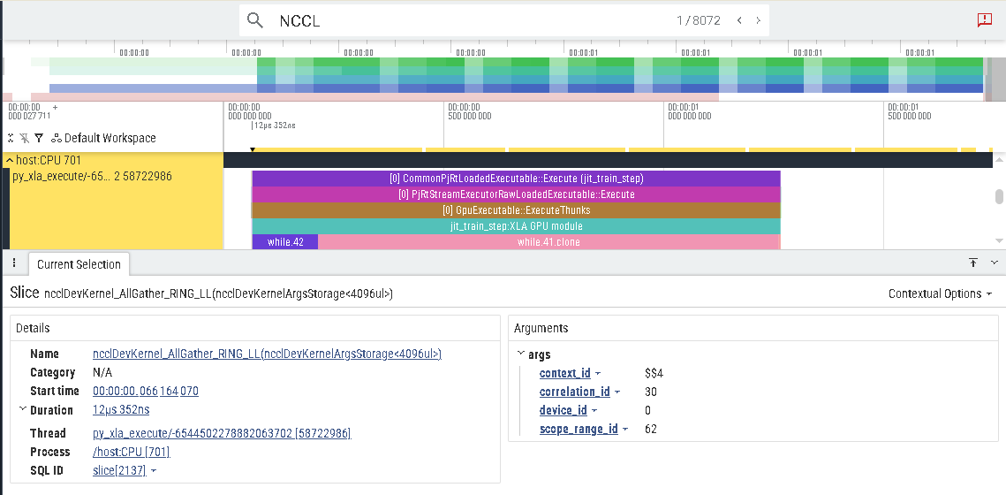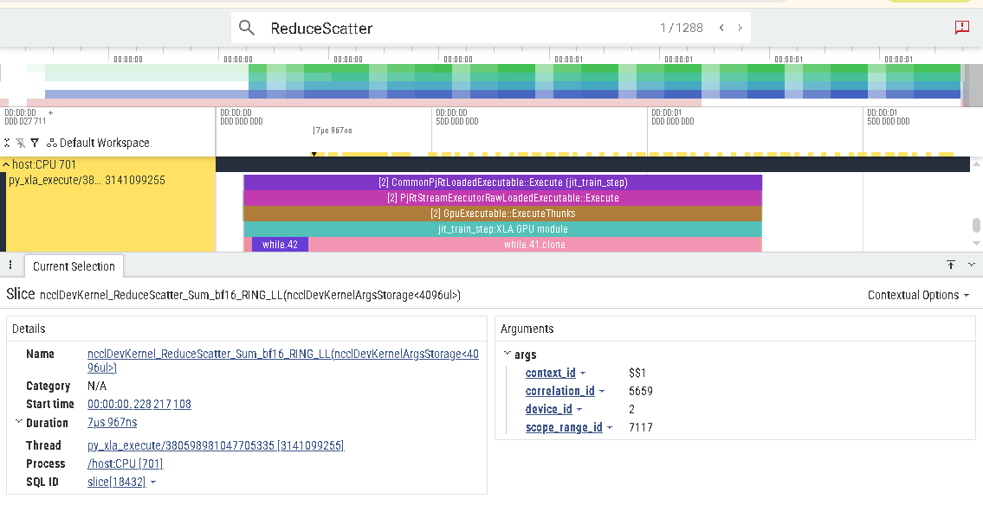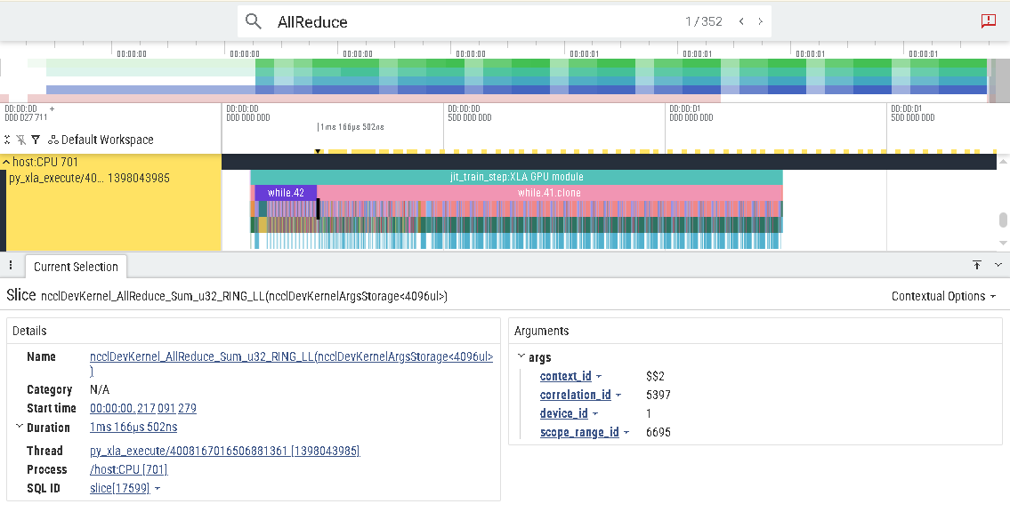

Question 2: Overlap Analysis
In the Perfetto trace, the NCCL communication blocks appear mostly sequential with compute blocks rather than overlapping. This means the GPU waits for communication to finish before continuing computation. In an ideal setup, communication should happen in the background while the GPU computes the next layer. The lack of overlap is a known limitation of the current FSDP configuration. Enabling CUDA_DEVICE_MAX_CONNECTIONS=1 helps schedule communication earlier, but full overlap requires additional tuning such as pipeline parallelism or async dispatch.

Question 3: Funky Factor
Looking at the backward pass, AllGather operations appear inside the backward pass, not just before the forward pass. This is because FSDP must re-gather weights during the backward pass to compute gradients — the weights were already freed after the forward pass to save memory. This creates an unusual pattern where the backward pass performs both weight reconstruction (AllGather) and gradient computation simultaneously, rather than a clean sequential flow. This is the standard FSDP memory trade-off: free weights early to save memory, but pay the cost of re-gathering them again during backward.
Another interesting observation: step 0 was extremely slow (~31 seconds vs ~1.65 seconds for later steps) because XLA was compiling the computation graph (JIT compilation). All subsequent steps ran at full speed, which is why the rules require skipping the first 10 warmup steps when measuring throughput.

Challenges & Solutions
Working on this task involved several real engineering problems that required debugging and creative solutions.

Disk Quota Exceeded During Profiling
When we first tried to run the xplane profiler with checkpointing enabled, the run crashed because scratch storage was full (~255GB across all runs). We solved this by removing unused run directories and disabling checkpointing for the profiling run, since only the trace file was needed.

Out of Memory (OOM) on Gradient Accumulation
We tried gradient_accumulation_steps=2 with per_device_batch_size=1 to simulate batch=2 with less peak memory. It crashed with OOM during checkpointing because each GPU was already using 41.27 GB / 85.5 GB just for parameters, leaving no headroom for gradient buffers and checkpoint I/O simultaneously.

Tensor Parallelism Was Slower, Not Faster
Mixing FSDP=2 and Tensor Parallelism=2 gave ~1,950 Tokens/s/device, which was worse than pure FSDP=4 with batch=2 (~2,468 Tokens/s/device). Tensor Parallelism adds frequent small AllReduce operations inside each layer, which is expensive on only 4 GPUs. This strategy works better at larger scale (8+ GPUs per node).

SSH Disconnections During Long Runs
Training runs lasted approximately 2 hours each. Several times the SSH connection was lost due to network timeouts. We learned to use tmux to keep training sessions alive even when disconnected, and always redirected output to a log file using tee so no data was lost.

Container Storage Issues
The default /tmp directory was too small to pull the container image, causing a 'no space left on device' error. We fixed this by redirecting TMPDIR and XDG_RUNTIME_DIR to scratch storage before launching podman, and configured container storage in ~/.config/containers/storage.conf.

Conclusion
In this work, we optimized training of the Alibaba Cloud Qwen 3 14B model on a single Romeo Cluster GH200 node using MaxText and JAX. The best configuration was pure FSDP across 4 GPUs with per-device batch size 2, achieving approximately 2,468 tokens/s/device and a 10.4% throughput improvement over the baseline while satisfying the final-loss requirement. Profiling showed that FSDP communication was dominated by AllGather operations, especially because weights must be reconstructed before both forward and backward computation. Mixed FSDP and Tensor Parallelism was slower at this scale due to additional synchronization overhead, while gradient accumulation failed due to memory pressure. Overall, the most effective optimization was increasing batch size while keeping the parallel strategy simple.
In addition to the performance analysis, this project highlighted several practical aspects of large-scale training on HPC systems, including storage management, checkpointing overhead, container runtime configuration, and maintaining long-running distributed jobs. These engineering challenges were as important as the model optimizations themselves and provided valuable hands-on experience in debugging and operating real-world distributed AI workloads.

